Overview
The Statistical Consulting Center at Florida State University is a research assistance facility for the students, faculty, and staff at FSU. The Center is a function of the graduate program within the Department of Statistics at Florida State University. The Statistical Consulting Center is a free service for members of the FSU community. When requested, clients from outside the FSU community are given at least a one-hour consultation. The Statistical Consulting Center also holds walk-in hours to assist clients on a first-come first-serve basis. Currently, the Consulting Center is also expanding to serve as analysts for grants needing statistical support. Services included but are not limited to:
Translating research questions and hypotheses into statistical terms
Designing sampling procedures
Choosing appropriate statistical methods
Interpreting computer output
Phrasing statistical results
Referrals to other statistical help
The Statistical Consulting Center generally does not perform actual analyses.
Walk-in hours for the 2011-2012 academic year were held on Monday-Thursday afternoons in Strozier Library Consultation Room A. Appointments were planned to accommodate both the consultant’s and the clients’ specific scheduling needs. The majority of appointments were held in person at the end of the week. Occasionally the consultant would answer questions via email or have a phone appointment if the client was not in town.
Summary of Business Activities

Graduate students Felicia Williams, Yuanyuan Tang, Jianchang Lin, Qian Xie, Wade Henning, and Mike Lugo served as the consultants for the consulting center this year. Felicia became the lead consultant this year after Kelly determined that she wanted to become a teaching assistant within the department. During the fall 2010 semester, Felicia and Yuanyuan were the primary consultants, while Jianchang and Wade took on observatory roles, observing the consulting sessions for the most part but later consulting with some clients on their own. During the spring 2011 semester, Felicia, Qian, and Wade were the primary consultants while Mike took on an observatory role.

On average, consultants had approximately 1 appointment every 3 weeks, for a total of about 30 appointments over the course of the two semesters. The demand was relatively high at the beginning of the semester and decreased significantly toward the end of the semester. There were also several cancellations of the appointments during the spring semester.

The task of holding walk-in hours was split up between the consultants. There was no appointment required during these hours. Clients were allowed to drop in whenever they wanted. The fall semester was busier than the spring.

Appointment Summary

PIE CHART

The majority of appointment clients this year were Doctoral students seeking assistance for the quantitative aspect of their dissertations. We also met with some Masters and Undergraduate students writing a thesis, working on a research project, or studying for a class. On a few occasions, faculty members were provided statistical advice for their research work. Over time, we are proud to say that we have been able to provide statistical services for clients from various departments of the University community as indicated below:

Anthropology
Art Education
Biology
Chemistry
Communication Disorders
Dance
Engineering
Exercise Science
Educational Psychology and Learning Systems Department
Family and Child Sciences
Family and Consumer Sciences
Fashion Design
General Education
Instructional Systems
Mathematics Education
Meteorology
Music Education
Music Therapy
Nursing
Nutrition
Oceanography
Physical Education
Physics
Psychology
Public Administration
Public Health
Social Work
Sociology
Sports Management and Recreation Management
Textiles and Consumer Sciences

Initial consultations and follow-up appointments were scheduled throughout the clients’ research processes until the completion of the statistical research. The most frequent statistical ideas used were t-tests, ANOVA, basic linear regression, logistic regression, Chi-square, factor analysis, power analysis, sample size calculations, and survey data analysis. The consulting center is currently able to advise clients as to the functions of computer packages such as SPSS, SAS, and Excel, but does not perform a client’s actual analysis.

Typical Cases

In the Spring of 2012, a student in the FSU Department of Education met with us for help with her dissertation. She had three key research questions: Does the number of developmental concerns predict referral completion, does the type of developmental concerns predict referral completion, and are there differences in child and family demographics between completed referrals and those that are not completed. This was a categorical data analysis and she had identified logistic regression as a possible tool. The client was not familiar with regression models, in general. We discussed ways to indentify key variables as well as suggested ways for her to organize her data. Ranking the predictive value of the variables was especially important to her, and we discussed chi-square attribute selection and odds ratio testing. The statistical software packages utilized by this client were MS Excel and SPSS.

In the Spring of 2012, a Marriage & Family Therapy student visited our walk in hours in Strozier Library for help on her undergraduate research project. She was studying the “Longitudinal Effects of Corporal Punishment on Disobedience”. She wanted to understand how to test ANOVA model assumptions, and how to implement ANOVA in SPSS. We discussed the D'Agostino-Pearson omnibus test of normality, Levine’s test of heteroscedasticity, and understanding study and sampling design to control for independence. The dependent variable, disobedience, was a categorical variable on a three point scale, thus allowing for a Logistic Regression model to be utilized. We discussed how one might set up this model, and how to evaluate attributes using chi-square attribute selection. Reference materials for these particular methods were also provided to the client.

Walk-in hours summary

PIE CHART
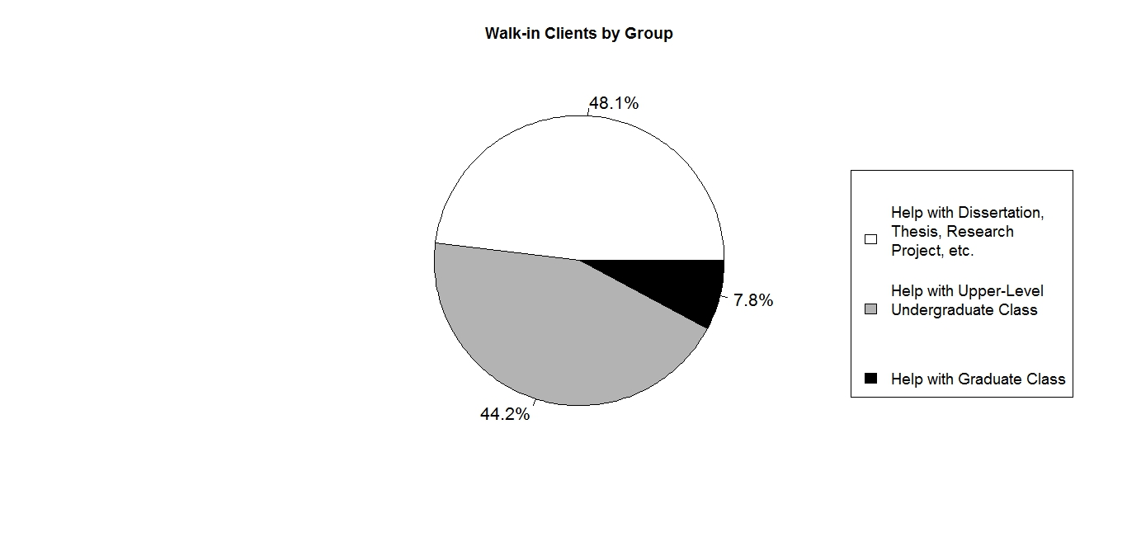

The majority of walk-in hours clients were looking for help with dissertations, theses, research projects, etc. at FSU. Many other students were regular visitors with questions about material pertaining to their graduate or undergraduate classes involving statistical analysis. Students came with both theoretical questions about statistical methodology and questions concerning software such as SPSS, and SAS. Those were by far the programs that students had the most questions about, and seemed to utilize the most. If clients were not able to be assisted during walk-in hours due the intensity of their questions, the consultants would recommend that the client make an appointment by way of the consulting e-mail address. Some clients would follow-up their appointment by coming in to walk-in hours or sending an e-mail to the consultant.

Below are a few of the courses we have been able to provide statistical consultation for within the past year:
PAD 5701- Quantitative Analysis in Public Administration
STA 4853- Time Series Analysis
ECO 4421- Introduction to Econometrics
STA 3024- SAS for Data and Statistical Analysis
EDF 5400- Basic Descriptive and Inferential Statistics
STA 4203- Applied Regression Methods
STA 4202- ANOVA and Design of Experiments
CCJ 4700- Introduction to Research Methods in Criminology

In addition to the departments represented above, student researchers also came from the following departments and colleges:
Middle-Eastern Studies
Social Work
Educational Psychology and Learning Systems
College of Education
Family and Child Sciences
Accounting
Mathematics
Nursing
Biology
Modern Languages
Communication Disorders
Information Systems
Business

Reflections
Once again, working in the Statistical Consulting Center has allowed us the opportunity to see the wide variety of fields where the discipline of statistics can be useful. From the perspective of a graduate student in Statistics, the Center is an opportunity to take what we have learned in the classroom and apply them to the real world problems. It has also been rewarding to know that in some small way we have been able to help so many different people in this collaborative research process.

